Rayat Shikshan Sanstha’s
Dr. Patangrao Kadam Mahavidyalaya, Ramanandnagar (Burli)
Faculty Profile

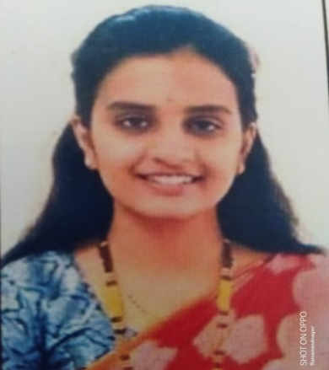

- Name: Mrs. Sayali Akshay Ghadage.
- Designation: Assistant Professor (C.H.B)
- Qualification: M.Sc.,SET.
- Department: Zoology
- Specialization: Animal Physiology
- Experience: 12 Months
- Contact No: 9022876047
- E-mail. Id: sghadage9197@gmai.com

